Cluster and Cloud Computing Assignment 1

Assignment 1 Report

Group Member 1  Name: Xinyu Zhou  Student ID: 1434696  Email: xinyu.zhou10@student.unimelb.edu.au | Group Member 2  Name: JUNLANG HU  Student ID: 1461262  Email: junlang.hu@student.unimelb.edu.au

[This is the cover page, please do not count as report page (: ] Reported: 11/04/2026

Introduction
This "Big Data Analytics" project develops a parallel MPI-based application to analyse large NDJSON datasets from Mastodon and BlueSky. The program extracts and counts language attributes from each record. The application is executed on the Spartan HPC cluster using Slurm and evaluated under different configurations of nodes and cores. Designed language extracting strategy and multiple parallelisation methods are implemented and compared for understanding the performance and scalability.

Metadata Language Extracting Strategy
Before implementing the final parser, sample records from the small and medium datasets were examined to understand the structure of the NDJSON files. This inspection reveals that the two data sources store language information in different JSON paths: BlueSky records use record.langs, while Mastodon records use doc.language."record":{... "langs": ["en"], ...}, "doc":{... "language": "en", ...}
The inspection also revealed several irregular cases containing Bad json(Malformed, although not sighted yet, but still needs to be handled), No lang paths(unmatched), no value in langs(empty), that needed to be handled robustly. Also, the extracted value was not always represented in the same format: some records stored languages as a list, while others used a single string value.
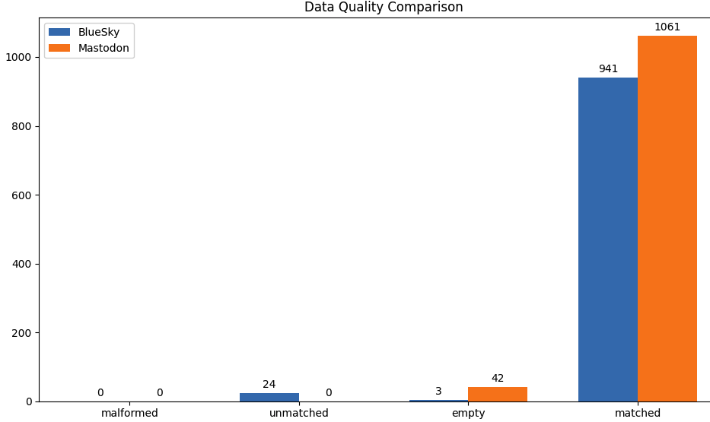  [Small Dataset Inspection] | 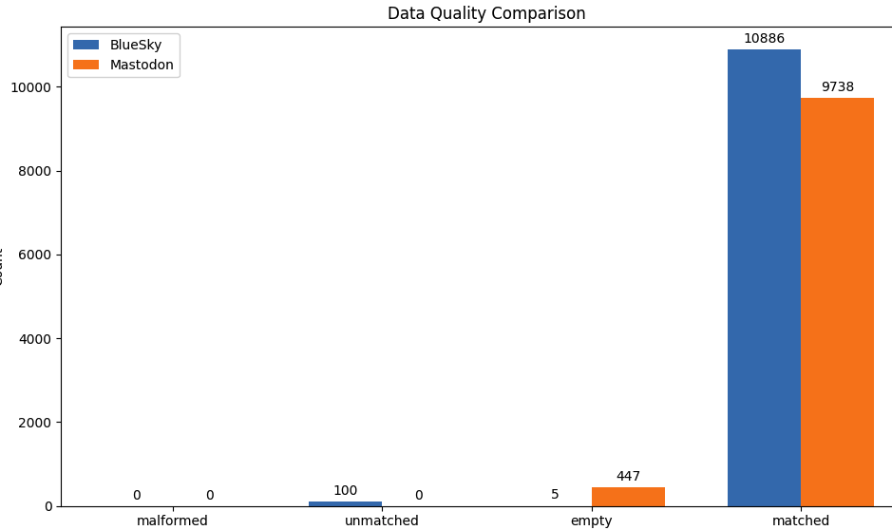  [Medium Dataset Inspection]
Based on these observations, a unified parsing strategy was implemented. Each line is parsed using json.loads, and the program then checks the known schema-specific paths to extract language metadata. If a valid language value is found, it normalises into a list so that downstream counting logic can remain consistent. If the record is malformed or no language value is available, an empty list is returned and the record is safely skipped.
Since design should prioritise data integrity and robustness. Hence, no NLTK's language prediction was used, because the task focuses on extracting language metadata already present in the dataset rather than inferring language from text content. Using prediction would introduce computational overhead and classification errors.

Parallelisation Strategies
The project explores three parallelisation strategies: linear modulo, chunking, and workerpool model. These approaches differ in how workload is distributed, from static partitioning to dynamic scheduling and show different trade-offs in structures.
MPI Communication (in Python)
The application is implemented using MPI with a data-parallel design(With python mpi4py). Each process is assigned a unique rank within the global communicator (MPI_COMM_WORLD) and performs local computation independently on a subset of the input data. Each process produces a local frequency counter, which is then aggregated using MPI collective operations. Eventually, MPI_Reduce is used to combine local results into a final global count at the root process (rank 0). Synchronization points are introduced using MPI_Barrier and execution time is measured using MPI_Wtime.

Method 1: Linear Modulo
In the line modulo strategy, work is distributed across MPI processes based on the line number of the input file. Each process reads the entire NDJSON file sequentially, but only processes the lines that satisfy the condition: "line_number mod(α) = rank". Where α is the total number of processes and rank is the identifier of the current process. After all processes complete their local computation, the results are aggregated using MPI collective operations (e.g., MPI_Reduce) to produce the final global counts.
Amdahl’s Law Discussion: From the perspective of Amdahl’s Law, this duplicated I/O processing increases the effective sequential component (1 − α) of the program, even though the computation itself was parallelisable, the file reading could not . Consequently, the achievable speed is limited despite the use of multiple processes. Overall, this strategy serves as a simple baseline for comparison with more advanced parallelisation strategies.

Method 2: Chunk
As for the chunking strategy, the input file is partitioned into contiguous bytes, and each MPI process is assigned a specific portion of the file based on its rank. Better than the linear modulo approach, each process only reads its assigned segment rather than the entire file, reduced redundant I/O operations. (Demo code, partially shown)
Python
chunk method logic demo
chunk_size = file_size // size; start_byte = rank * chunk_size
with open(file_path, "r", encoding="utf-8") as f:
f.seek(start_byte)
if rank != 0: f.readline() #Boundry handling, skip start line except rank 0
The size of each chunk is determined by dividing the total file size by the number of processes. Since NDJSON records are line-based, chunk boundaries may split individual records. Hence, processes (except rank 0) skip the first partial line, ensuring complete records are processed.
Amdahl’s Law Discussion: Overall, this approach significantly improves I/O efficiency and scalability, particularly for large datasets, as it avoids repeated file reads across processes. However, it introduces additional complexity due to boundary handling. From the perspective of Amdahl’s Law, comparing to previous method, reducing redundant I/O decreases the effective sequential component (1 − α) of the program, thereby increasing the parallel portion (α) and enabling greater speedup. However, boundary handling and potential load imbalance still contribute to the non-parallelisable portion, limiting perfect scalability.

Method 3: Worker Pool
Very different from the first two strategies, the worker-pool strategy adopts a "master–worker" model in which one process acts as a coordinator and dynamically assigns tasks for the worker processes. Unlike static pre-partitioning approaches used in line modulo and chunking, this strategy distributes work on demand. In this design, worker processes repeatedly communicate with the master indicating their availability. The master responds by assigning a batch of data (e.g., a group of lines) to each requesting worker. Once the assigned task is completed, the worker sends another request for additional work. (Demo code, partially shown)
Python
def master_logic(file_path, size): status = MPI.Status()
... while True:
comm.recv(source=MPI.ANY_SOURCE, tag=TAG_READY, status=status)
comm.send(line_batch, dest=worker_rank, tag=TAG_TASK)
def worker_logic(language_extractor):
... langs = language_extractor(line)
Amdahl’s Law Discussion: From the perspective of Amdahls Law, dynamic load balancing increases the effective parallel portion (α) by reducing idle time of processes. However, as stated earlier, the additional interprocess communication cost and coordination overhead increase the sequential component (1 − α), which defines the overall bottleneck. As the number of processes grows, this overhead becomes more significant, reducing scalability. Overall, this strategy demonstrates trade-off between improved load balancing(α) and increased communication cost(1-α) and master pressure.

Execution(Slurm script) & Result
The main slurm script is displayed below: the 1n8c chuck strategy.
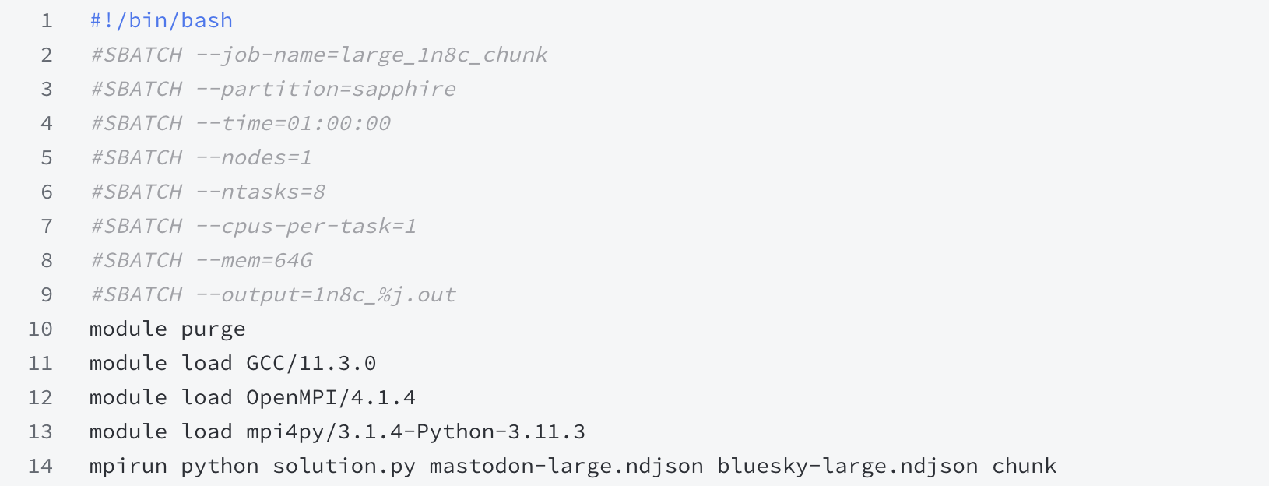
The Result for large file language parsing (From Chunk 1n8c)
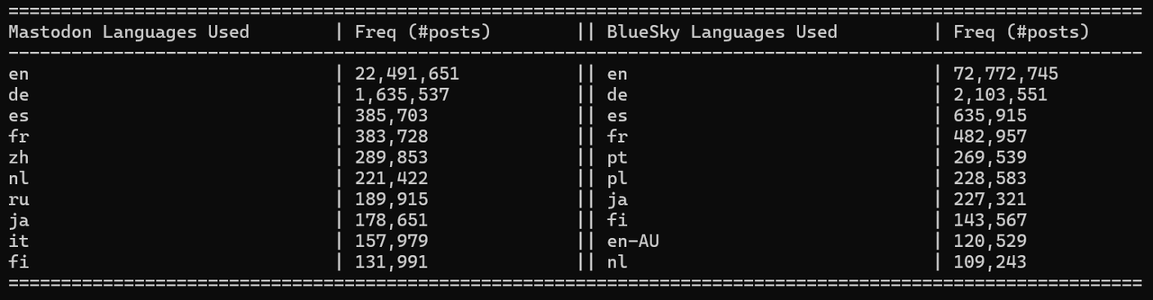
Strategy Time Comparison(Under medium file)  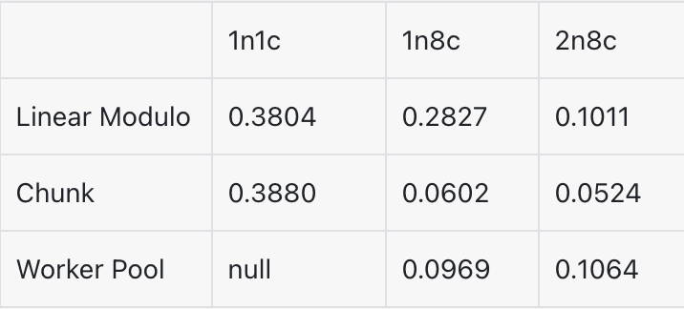 | Final Large file executing (in seconds)  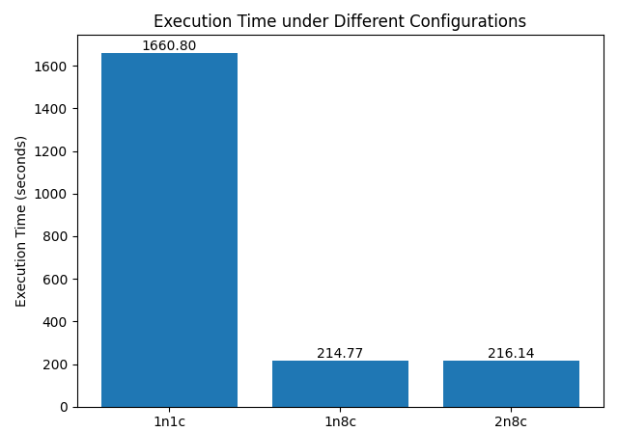

Discussion(Amdahl’s Law)
Recalling Amdahl’s Law S(N) = 1 / ((1 − α) + α / N), the experimental results obtained can be interpreted through it, which states that the overall speedup of a parallel program is limited by the fraction of the workload that must be executed sequentially. For processing with chunking strategy on the large data, increasing the number of cores from 1 to 8 leads to a substantial execution time reduction, indicating that the majority of the workload is parallelisable (α/N).
However, further increasing from 1 node to 2 nodes does not result in additional performance improvement. Instead, extra time costs occurred. This suggests that communication and coordination overhead, which form part of the non-parallelisable component (1 - α) of code, is the bottle neck. Which fits Amdahl’s Law, these elements always limit the achievable speedup even when more computational resources are added.
Overall, the results demonstrate that while parallelisation can significantly reduce execution time, as N increases, the term α / N reduced, and the overall speed becomes increasingly dominated by (1 − α). But its effectiveness is always constrained by both I/O and communication overhead. These factors represent the sequential portion in Amdahl’s Law and explain the performance gains observed when scaling beyond a single node.

Appendix LLM Declaration
This project received minor assistance from large language models for both implementation support and report writing. The use was only limited to research and information gathering. Code implementation and report construction and analysis were done on our own.
For the coding component, the LLM was used to assist understanding of MPI and components(methods, logic) about mpi4py. All core logic, including the design of parallelisation strategies , was developed independently.
For the report part, the LLM was used to refine wording and language choice. Some interaction involved discussing how to describe parallelisation trade-offs and Amdahl’s Law. The final content reflects the our own understanding and interpretation.
In general, the LLM was used as a support tool for better understanding and studying of the project.
Involved LLM: Gemini, Chatgpt.

